

**32 OCs STILL AT SEA**

**(29th May 2016)**

54-56 Captain C. Robert **Hilton**

*“Did a brief relief as mate because of another man's drinking ("Was he not drinking enough?" an admirer asked). I'm still available to be dug up when needed.”*

56-58 Emlyn **Jones**

Pilot/ Harbour Master/Mooring Master in Trinidad.

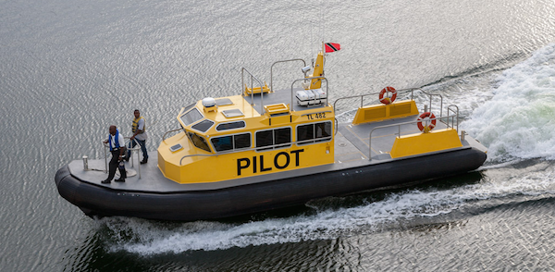

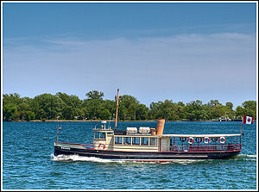

59-60 Captain Geoff **Rae**

Having retired from the sea Geoff is now running a busy schedule across Toronto Harbour as skipper of [*Kwasind*](http://en.wikipedia.org/wiki/MV_Kwasind) for the [Royal Canadian Yacht Club](https://rcyc.ca/MEMBERSHIP/COMMUNICATIONS/Kwasind.aspx). Almost full circle as his sweep was the pinnace in *Conway*!

60-62 Captain Howard **Crowther** - does relief work in super yachts.

60-62 Captain J D (Don) **McGill**

Master of the container ship [*Southern Pearl*](http://maritime-connector.com/ship/southern-pearl-9264207/) which island hops around the Pacific.

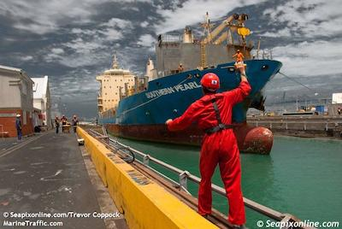

61-63 Captain Chris **Puxley** pilots the [Solway Firth](http://www.solwayshipping.com) shallows to and from the small but busy commercial [Port of Silloth](http://www.abports.co.uk/Marine/Short_Sea_Ports/Silloth/).

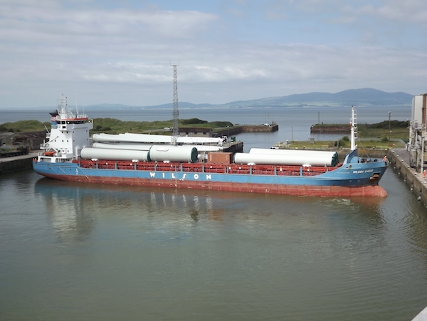

*Wilson Cadiz turning within the New Dock at Silloth on a rare wind-free day.*

62-64 Donald (King Cam) **Campbell**

Master of a [Pritchard-Gordon tanker *Mt Lesley PG*](http://www.pgtankers.com/lesley_pg.php) in the Caribbean.

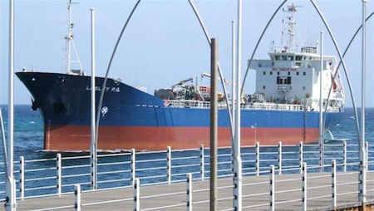

62-65 Peter **Eaton** - Pilot, [Manchester Ship Canal](http://peelports.co.uk/port-authorities/manchester-ship-canal).

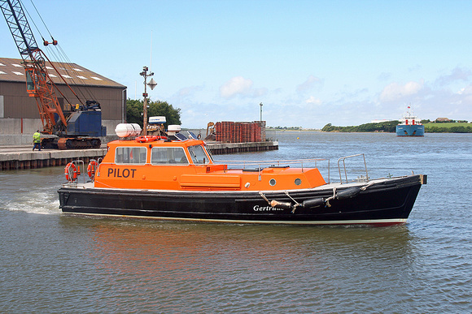

63-64 Captain Mike **Dawes** - Master of [*Pacific Wrestler*](http://www.swire.com.sg/Fleet/Vessel-Search.aspx) for [Swire Pacific Offshore](http://www.swire.com.sg) operating at Barrow Island, [Gorgon Gas Project](http://en.wikipedia.org/wiki/Gorgon_gas_project), NW Australia.

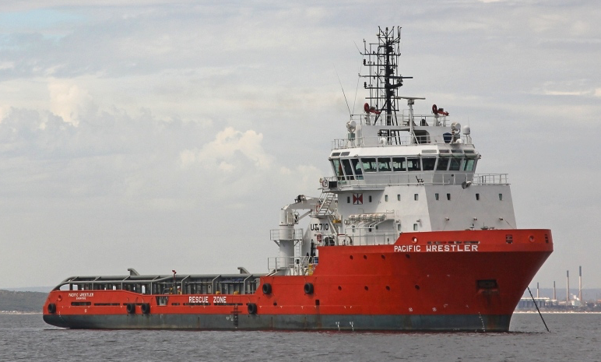

63-65 Captain Chris **Blunt** - still running Superyachts, based in Palma but spend winters in the Caribbean *“which keeps me young”.*

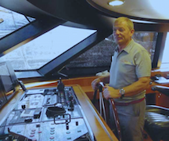

63-65 Captain Peter **Howland** - “*I have been called out of retirement to take command of* [*Merkur Ocean*](http://www.vinnen.com/en/flotte/mv-merkur-ocean) *aka "Cap Coral". On charter to Hamburg Sud for next five years trading far east to Aussie and New Zealand.”*

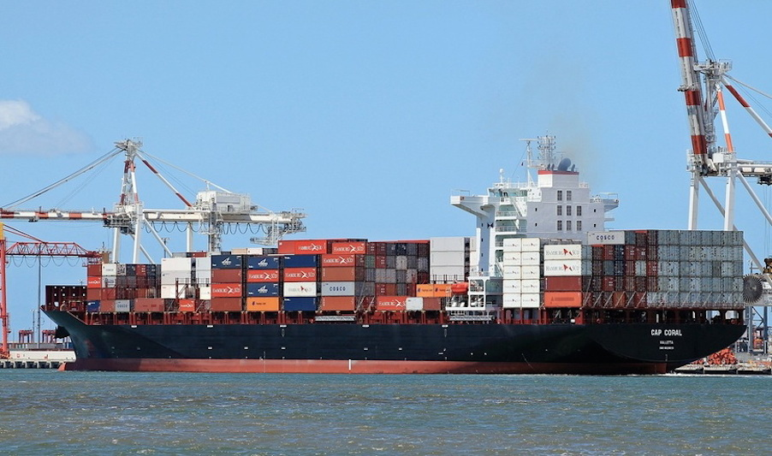

63-65 Captain Brian **Larcombe** - Now master of Linblad Expeditions’ cruise ship [*National Geographic Orion*](https://www.expeditions.com/destinations/antarctica/ships/national-geographic-orion/) and taking her through Indonesia and the Kimberleys (Australia). May do another stint later in year to Antartica.

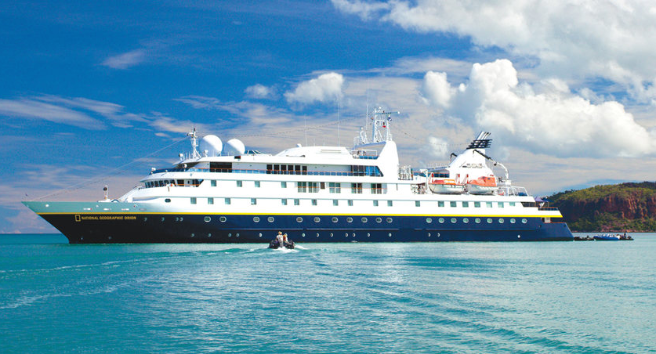

63-65 Captain Paul **Winstanley** –

Master of [*Maersk Atlantic*](https://www.fleetmon.com/en/vessels/Maersk_Atlantic_2148838) which does a weekly feeder run from Singapore to Indonesia and then back to Tanjung Pelepas and Singapore.

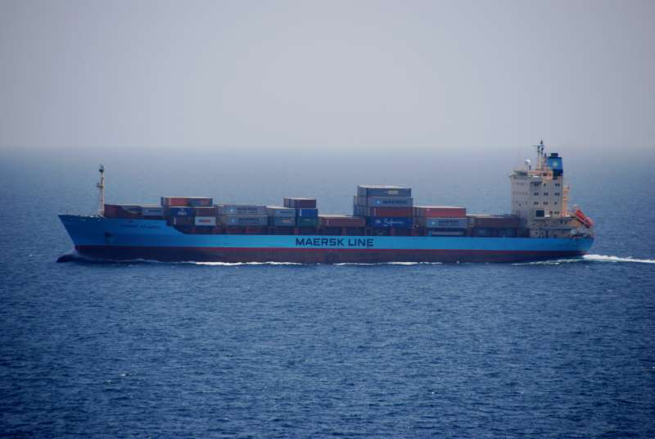

63-66 Captain Roy **Dearman** - Relief Master Thomson Cruises.

63-66 Martin **Ransome** - is apparently sailing in the Caribbean with his wife in [*Bequia*](http://www.charterworld.com/news/27m-sailing-yacht-bequia-stephens-warning-yacht-design) but he does some anchor handling work.

63-66 Roger **Stuart** - Mooring Master of [Exxon Mobil’s Nigerian](http://www.exxonmobil.com.ng/nigeria-english/pa/about_who_mpn.aspx) offshore oil terminals.

64-66 Chris **Walsh** - Pilot, Dubai.

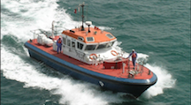

66-69 David C. **Clarke**

2nd Officer / relief Chief Officer, [*Stena Britannica*](http://www.marinetraffic.com/ais/details/ships/235080274) on the Harwich - Hoek van Holland service. She is the World's largest Ro-Pax ferry with a cargo capacity in excess of 5,000 lane metres.

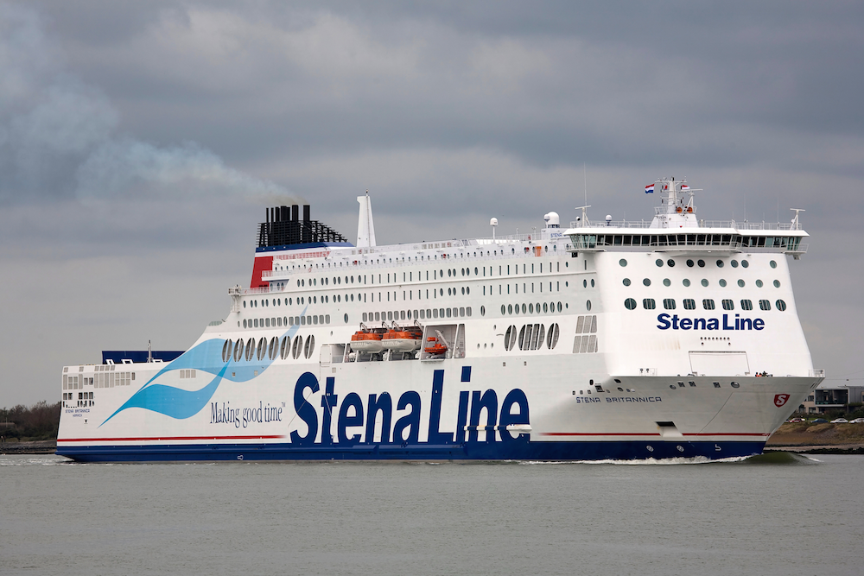

66-69 Phil **Henderson** - [Pilot, Manchester Ship Canal](http://peelports.com/wp-content/uploads/2014/11/MRG1-Pilotage-Directions.pdf).

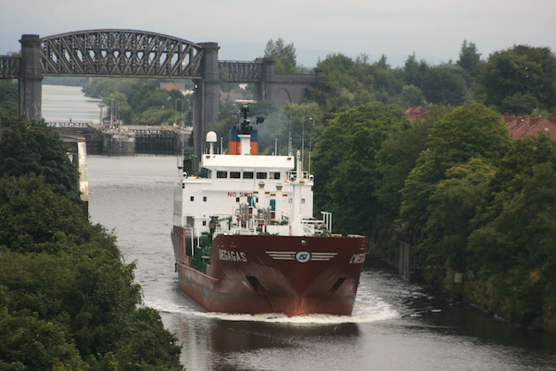

66-69 Mike **Lee** was Environmental Compliance Officer with Carnival Cruises but is now reported as sailing in [Cunard’s Queen Victoria](http://www.cunard.co.uk/cruise-ships/queen-victoria/?utm_source=ppc&utm_medium=google&utm_campaign=%5Bdimension%5D&gclid=COjJ-Lbt-LoCFQHHtAodG30AxQ).

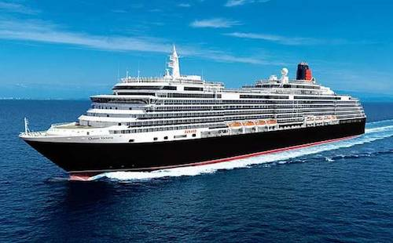

67-68 Captain Neil **Humphries** - Master [*Stena Nordica*](http://www.stenaline.co.uk/ferry/our-ships/stena-nordica/), Holyhead to Dublin.

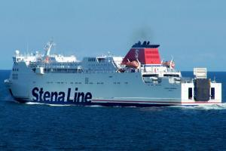

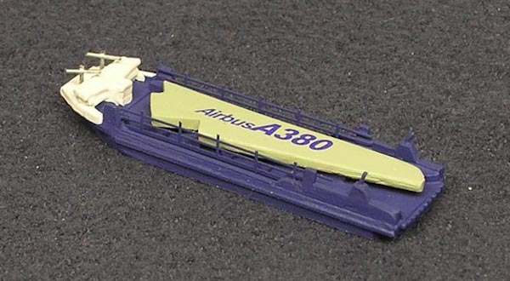67-68 Nigel **Williams** - Chief Engineer on  [*Arfon Dyfrdwy*](http://www.holyheadtowing.co.uk/vessels/afon-dyfrdwy/). This is specially designed ship to carry the Airbus A380 wings down the river Dee from Broughton to Port Mostyn.

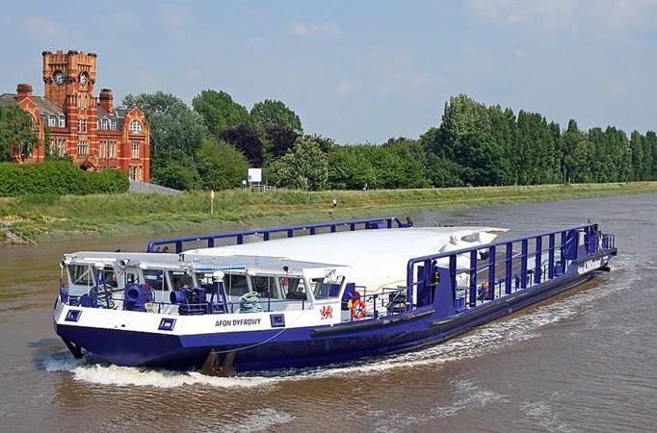

67-70 Hugo **Breen-Turner**

Chief Engineer[, Stena *HSS Explorer*](http://www.youtube.com/watch?v=bEdl_Ao9YxE), the biggest, fastest RoRo in the World powered by 4 GE Gas Turbines. Holyhead to Dun Laoghaire.

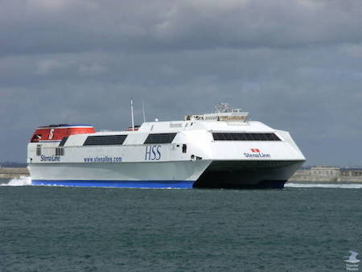

67-70 Captain Kenneth C **Robinson** - Captain/fish master of [MV *American Triumph*](http://www.marinetraffic.com/ais/details/ships/shipid:424326/mmsi:366047000/imo:0/vessel:AMERICAN_TRIUMPH), [South Pacific Tuna Corp](http://sopactuna.com) (San Diego).

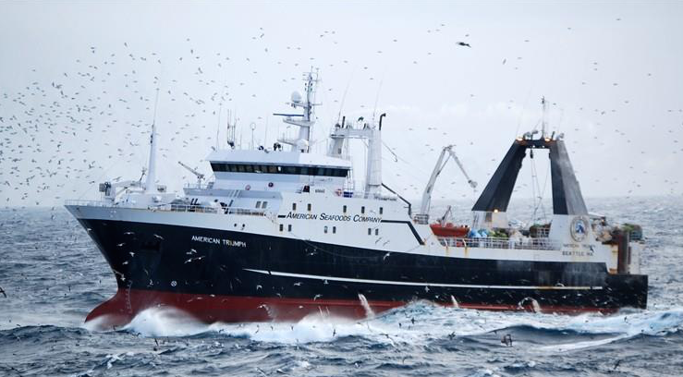

67-70 Alf **Wynne-Jones** - Chief Engineer in [Technip’s](http://www.technip.com/en) diving support vessel [*Orelia*](http://www.technip.com/sites/default/files/technip/fields/orelia_low_res_221112_0.pdf) in the North Sea.

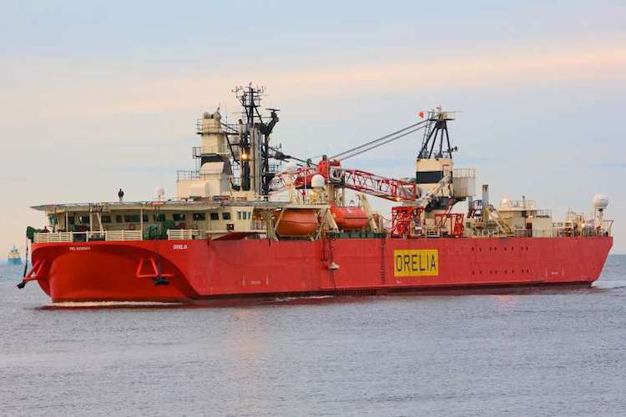

67-71 Captain John **Harbord** - Master container ship [m.v. *Maersk Leon*](http://www.marinetraffic.com/ais/details/ships/566405000/vessel:MAERSK_LEON), trading between Far East (Singapore, Hong Kong, China and Korea) and South America (Brazil, Argentina and Uruguay).

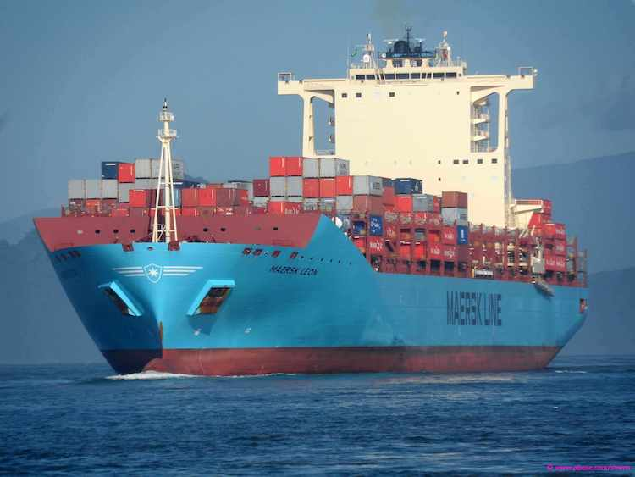

68-71 Dave **MacVicker** is a [Shoreham](http://www.shoreham-port.co.uk) Pilot.

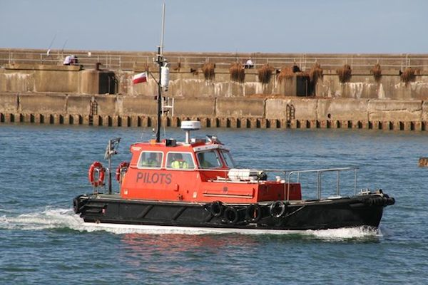

69-71 Andrew **Wright** - Master of [Trinity House’s](http://www.trinityhouse.co.uk) Navigational Aids Tender *Mair*.

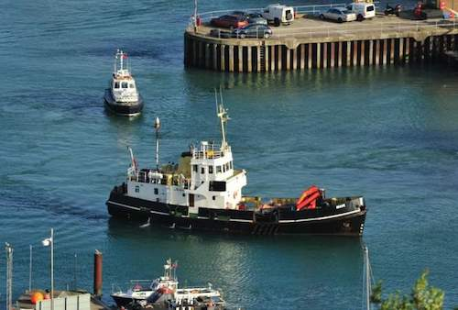

71-73 Captain John L. **Davidson** - Currently serving as Master of [*Maersk Nascopie*](http://maritime-connector.com/ship/maersk-nascopie-9104029/print/) out of St John's Newfoundland, servicing the Hibernia Production.

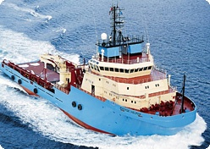

71-73 Matt **Winter** - is now [Pilotage Manager, Southampton](http://www.southamptonvts.co.uk/Pilotage/) but still does the occasional act of pilotage.

71-74 Pippa **Nicolas** *- “My licence is still valid as Chief Engineer. I run* [*Yachtprojects International*](http://www.yachtprojects.net) *and still get to do a few sea trials, commissioning trips and proving trips for new communication systems. Mostly commercial shipping today but occasionally yachts.”*

**Retirements (since Feb 2016)**

66-68 Peter **O'Donnell “***I left the Vos Master for the last time at the end of March.  My Chief's ticket needed revalidating this month and decided not to revalidate and join the ranks of the retired mariners”*

If you are still serving at sea please email [alfie@hmsconway.org](mailto:alfie@hmscomnway.org) or write to him at 2 French Grass, Bradford on Avon, Wilts, UK, BA15 1DX so your details can be included and to keep us up to date with your whereabouts.