OLD CONWAY KEITH MICHAEL SAULL RNZN CB(43-45)

Date & Place Of Birth
24th August 1927, Hipperholme, Yorkshire.

Previous School
Altrincham Grammar School.

Conway Dates
Joined: April 1943.
Left: April 1945 and is shown as RNR rather than a shipping company. He had passed his RN exams in February 1945 so he went straight to the RN as a Midshipman. However later reports show him as RNZN.

Cadet Number

Next of Kin Listed
Father Mr Harold V Saull, a woodware manufacture of Kennisdale, Warwick Drive, Hale, Cheshire.

Performance
Naval Reports: His conduct moved from Very Good tin 1944 to Excellent on leaving. His class placing varied greatly from 1st in 1943 to 49th (last) in 1945! As he rose to become and Admiral in the RNZN he might be judged a nautical late developer.
Academic Reports: His conduct was always Good until his last term when it moved to Very Good

Achievements
He was keen rower being stroke of the Starboard Fore 12 man cutter in 1943, stroke of the Port Maintop cutter in 1944 and rowing No., 3 in the “Nestor” four man gig crew which won the Parker Cup for inter-top races.
He played in the rugby 1st XV in his last term but, unusually, had made the 2nd XV in his first year.
He was Senior Cadet Captain of Maintop, i.e. a prefect, in charge of about 40 other cadets.
Passing Out Certificate: He achieved an Ordinary Certificate from his passing out exams, his conduct was rated Very Good and his ability Average.

Other Details
His marriage was recorded in The Cadet magazine in April 1953 – to Lin Barnsdale of Invercargill, NZ. He was then a Lt RNZN.
There is a profile and photo of him on http://navymuseum.co.nz/saull-rear-admiral-keith-micheal/
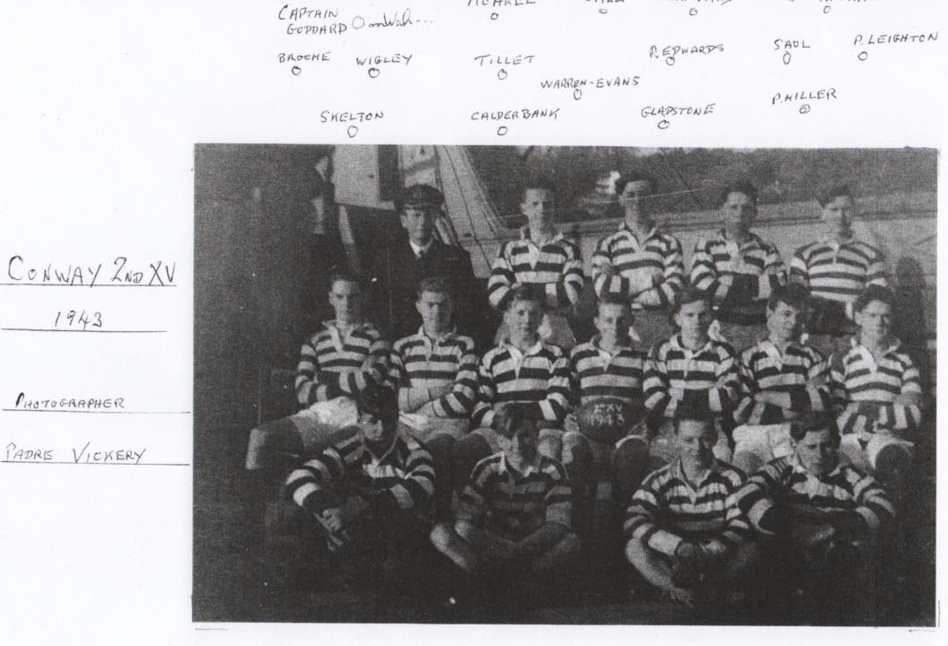
Above: Rugby 2nd XV 1943

Below: 1945 1st XV – he should be there somewhere.
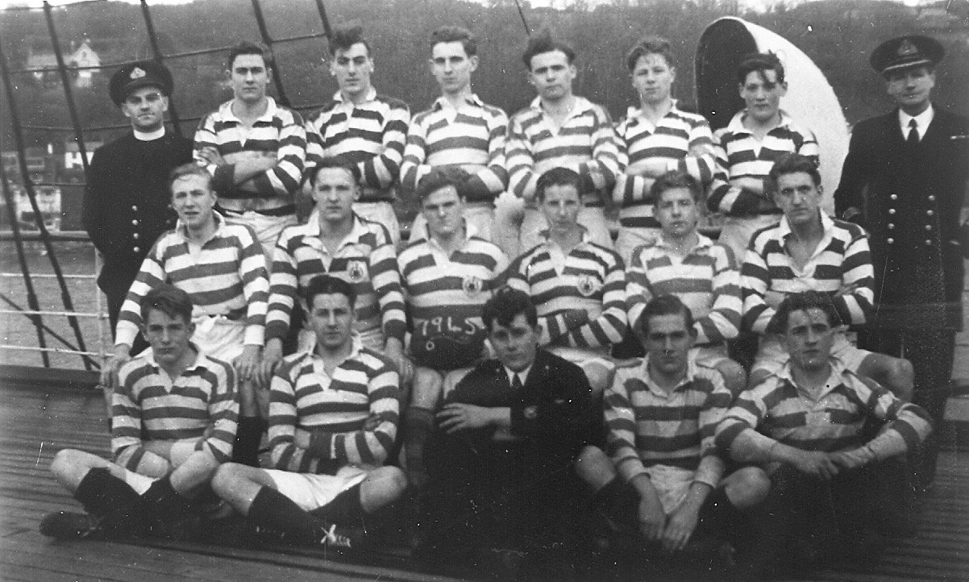

Below: Three photos of his term as they finished their training. He’s in there somewhere!
