Navigators & General
1921
Merchant Navy & Air Line Officers Assn. (MNAOA)
1956
(NEOU, Marine Engineers Union)

British Merchant Services League (MSL)
1919 - 1921
Imperial Merchant Service Guild
(IMSG)
1893 -1936

The ‘Federation’
1928
Capt Coombs first President

Zurich subsidiary
1998 (legal entity removed 2008)
Transition from campaigning group to welfare and social organisation from 1940s
The Watch Ashore Founded 1933 by
Hon. Mrs Nelson-Ward
and Mrs WH Coombs

NUMAST
(MMSA,MNAOA)

NUMAST became Nautilus UK in 2008 and Nautilus Int in 2009
Navigating and Engineering Officers Union (NEOU) 1935
Mercantile Marine Services Association (MMSA)
1857 – Now in Nautilus Int
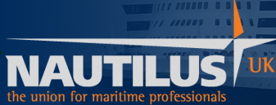

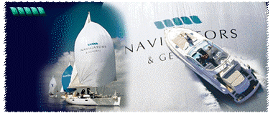
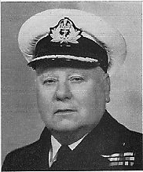
Eagle Star subsidiary
1960
‘Members’ of the Navigators joined NEDU in 1935 and N&G adopted a traditional Insurance role

Merchant Navy Officers Pension Fund 1937
Capt Coombs first Chairman of Trustees

The influence of Captain WH Coombs and ‘The Navigators’ on improving conditions for Merchant Seamen from 1921 to 2011

