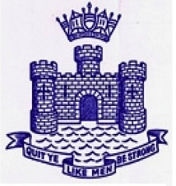

CONWAY ARCHIVE RECORD

CADET PHILIP ERIC BENT 1901 -1910

Left CONWAY December 1910 to join Sailing Vessel “VIMEIRA”.
Passed 2nd Mates ticket 1914

Volunteered for the Army on the outbreak of 1914-18 War.
Joined up as a Private and gained rapid promotion and was killed at the rank of Lt.Colonel in 1917 Awarded a posthumous VICTORIA CROSS

ARMY RECORD

Private A Company 1st Battalion City of Edinburgh, Royal Scots, Edinburgh Castle

7th Leicestershire Aldershot Corporal 1915

9th Leicestershire N0. 10 Camp Pereham Downs , Andover. July 1915

9th Leicestershire BEP France October 1915

9th Leicestershire Major – Colt December 1916

9th Leicestershire Lt. Colonel April 1917 D.S.O. awarded August 1917

December 1917 Lt.Col. Philip Eric Bent D.S.O Killed in action

