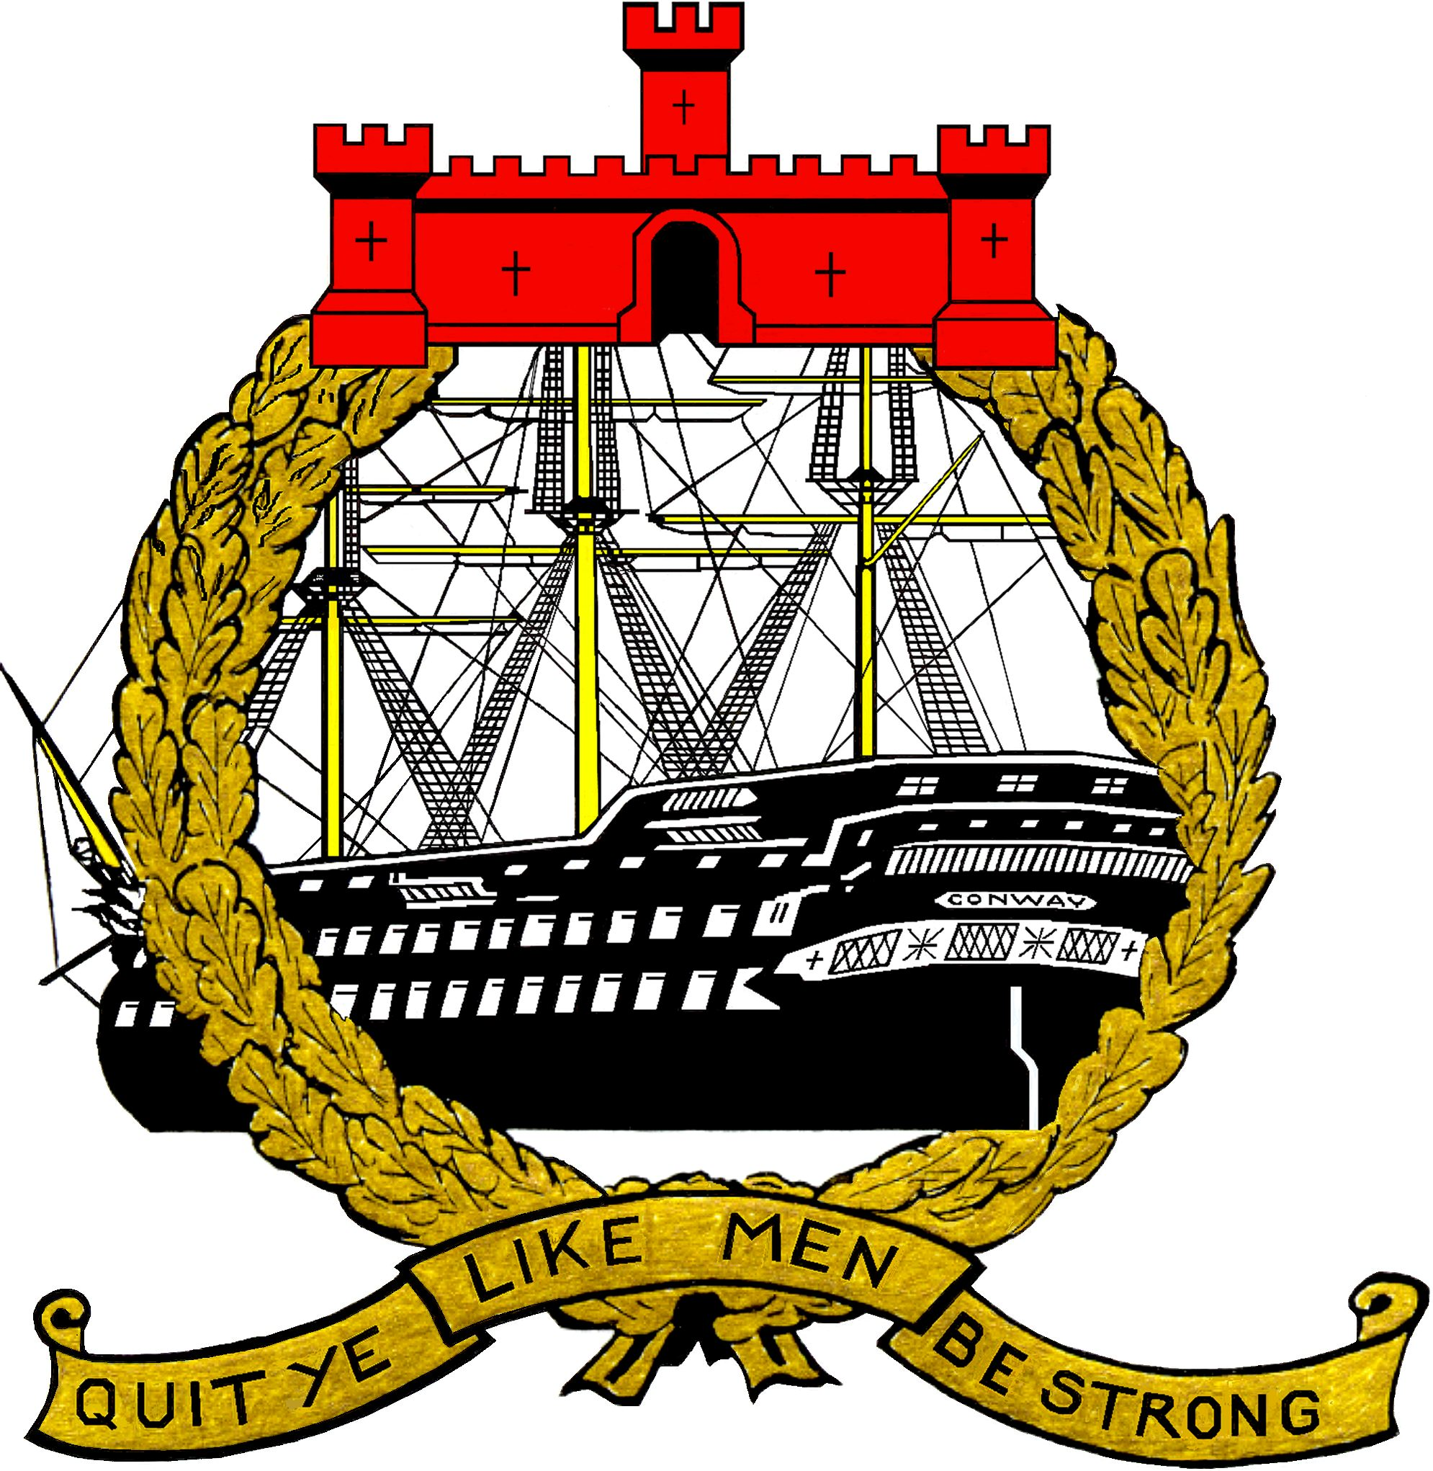

CONWAY ARCHIVE RECORD

CADET PHILIP ERIC BENT

Cadet Name Philip Eric Bent Conway No. 197
Born 3rd January 1891 Halifax Nova Scotia

Parent or Guardian Mrs Bent Superintendent
Occupation R.M.S. Halifax

Address Church Villa, Fordingbridge, Salisbury.
Clyde House, Surbiton Road, Kingston upon Thames.

Last School Grammar School, Ashby de la Zouch, Leicestershire.
Admitted January 1909
Left December 1910

CONWAY EXTRA LEAVING CERTIFICATE ISSUED
December 28th 1910 Conduct – Very Good Ability – Very Good

REMARKS
December 1910 - Promoted Senior Cadet Captain – Port Maintop
St John’s Ambulance First Aid Certificate Issued December 1910

Left to Join Sailing Ship “ Vimeira” Messrs J. Hardie & Co. Glasgow.

Passed 2nd Mates Certificate 1914

Volunteered to join Army at the outbreak of the 1914/18 War

SAILING SHIP VIMEIRA

A four masted steel Barque built 1891 by Charles Connell & Co Glasgow
Owner J. Hardie & Co. Glasgow
Launched at the shipyard of Charles Connell7 Co Glasgow British Reg No. 98650
Dim: 86.35mts x 12.92mts x 7.48mts - (283ft 4ins x 42ft 5ins x 24ft 7ins)
Sistership to the same owners four masted barque “Pryrenees” 1891

